# Traditional Static Assignment Route Choice Equilibration Test cases:

All test cases are implemented using the basic csv I/O. Resources can be found under src/test/resources/route_choice directory of the PlanItXML Java project.

## Test Case 1 (TIPI): Multiple ODs – no route choice

This test case should converge after the first iteration. The network looks like the following

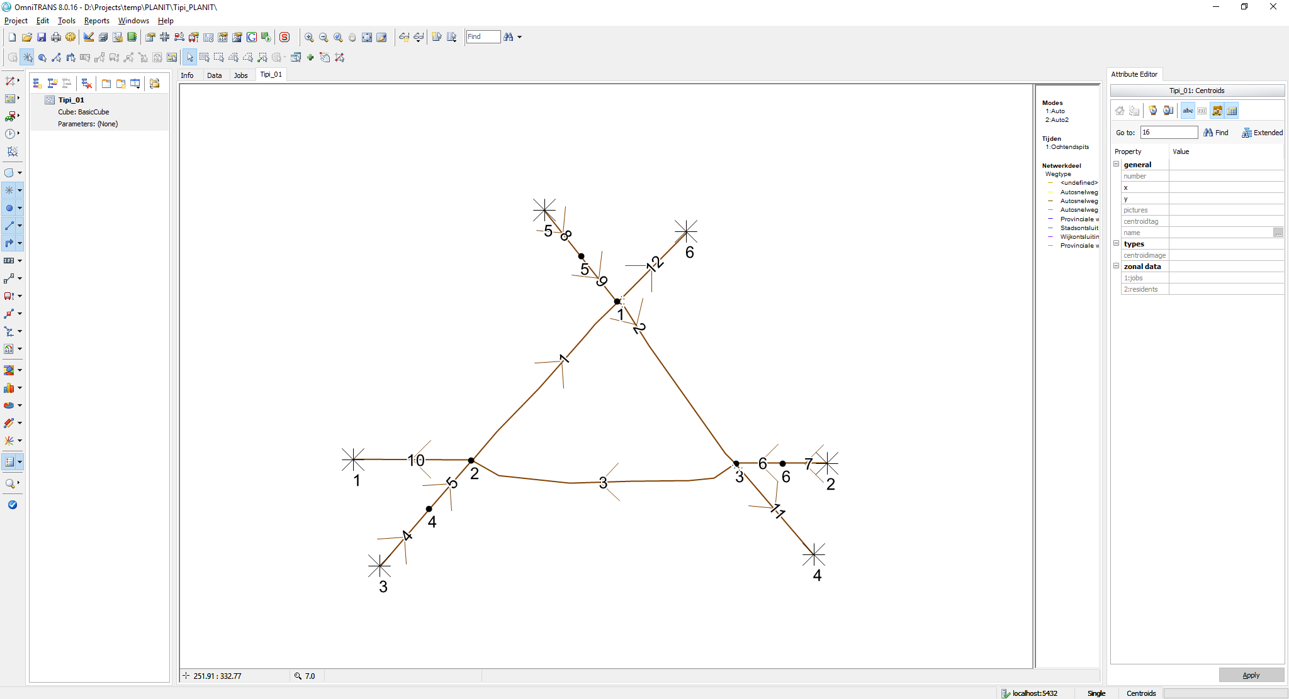

Figure : Multiple ODs, single route network.

**Length:**

* All links have a length of ***1 km***

**BPR**:

* All links use a BPR cost function with ***alpha: 0.5*** and ***beta: 4.0***

**Link properties:**

* All links have a maximum speed of ***100 km/h*** and a capacity of ***2000 veh/h/lane***, except for link 2 which has a capacity of only ***1000/veh/h/lane***
* All links have ***1 lane,*** *except links 4,7 and 8*who have ***10 lanes***

**Demand:**

* Travel demand is only non-zero on ODs 3,4 and 5,1 and 2,6. All three ODs have a travel demand of ***1000*** ***veh/h***

**Simulation:**

* Simulation time, i.e. period is ***1 h***.
* Single mode only

The resulting flows should like the following

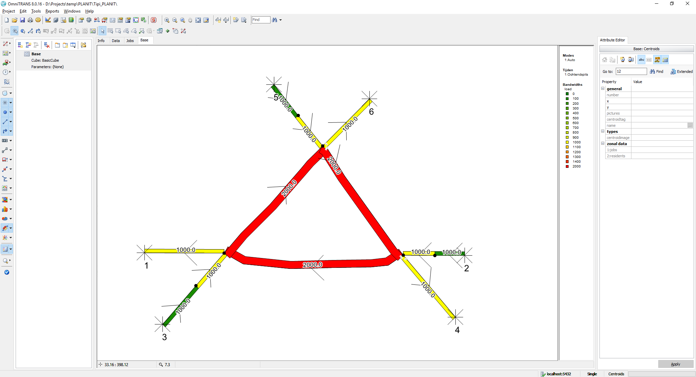

Figure : Equilibrium flow rates

Travel times (h) on the links are the following:

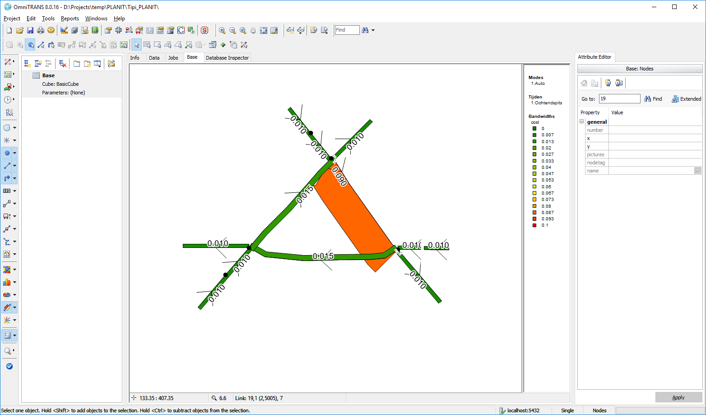

Figure : Generalised link cost in hours

## Test Case 2 (Mountain): 1 OD – 3 alternative routes

The network looks like the following:

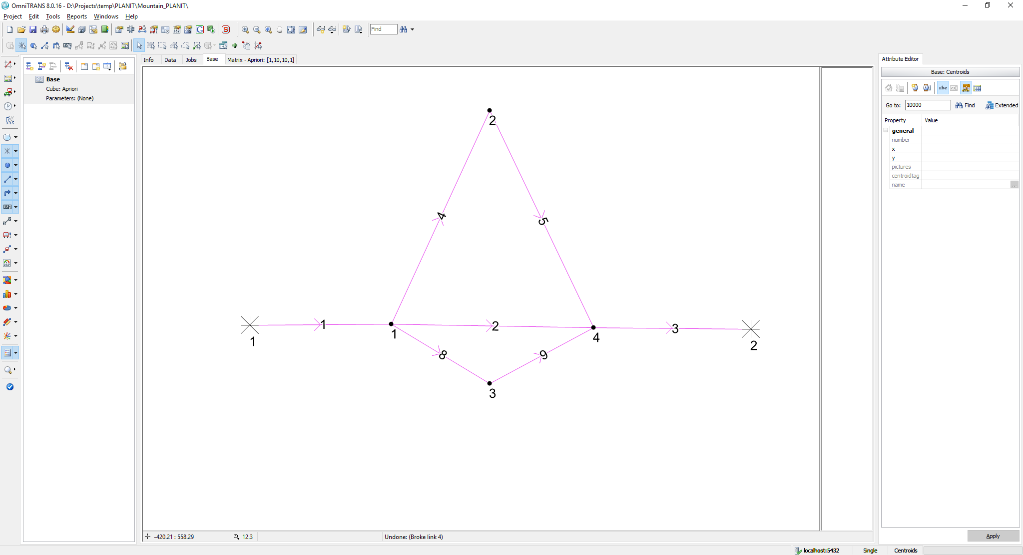

Figure : one OD, three route network.

**Length:**

* All links have a length of ***1 km***, except for links 4 and 5 which are ***2 km*** in length

**BPR**:

* All links use a BPR cost function with ***alpha: 0.5*** and ***beta: 4.0***

**Link properties:**

* All links have a maximum speed of ***60 km/h*** and a capacity of ***1200 veh/h/lane***.
* All links have ***1 lane***, except for links 1 and 3 who have ***3 lanes***

**Demand:**

* The travel demand from 1 🡪 2 is set to ***3600 veh/h***

**Simulation:**

* Simulation time, i.e. period is ***1 h***.

The equilibrium result after 500 iterations using regular MSA smoothing should yield the following link flow rates (Using OmniTRANS 8.0.16 and OTTraffic):

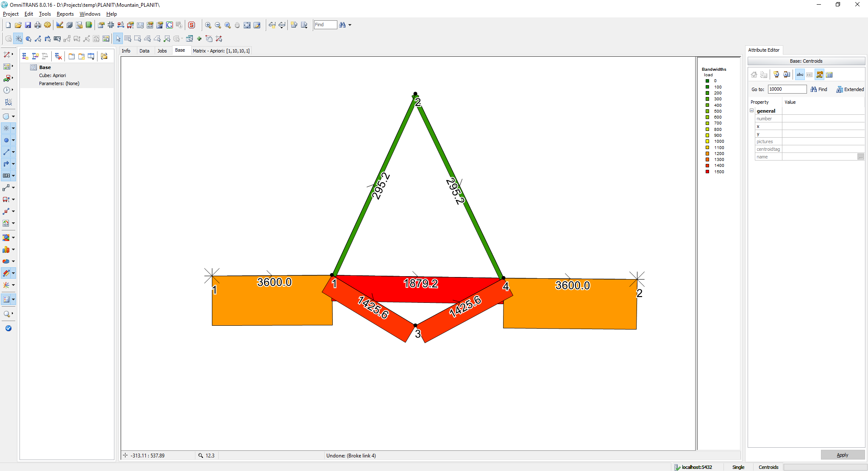

Figure : Equilibrium flow rates

The generalised link costs in terms of link travel times (h) are:

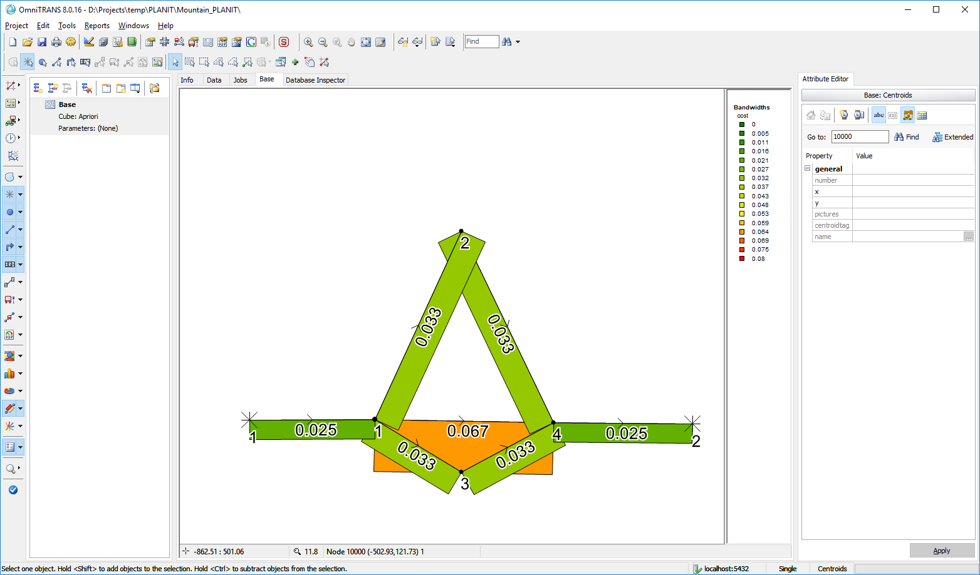

Figure : Generalised link costs in travel time (h)

## Test Case 3 (BRA): 1 OD – 4 alternative routes with interactions

The network looks like the following:

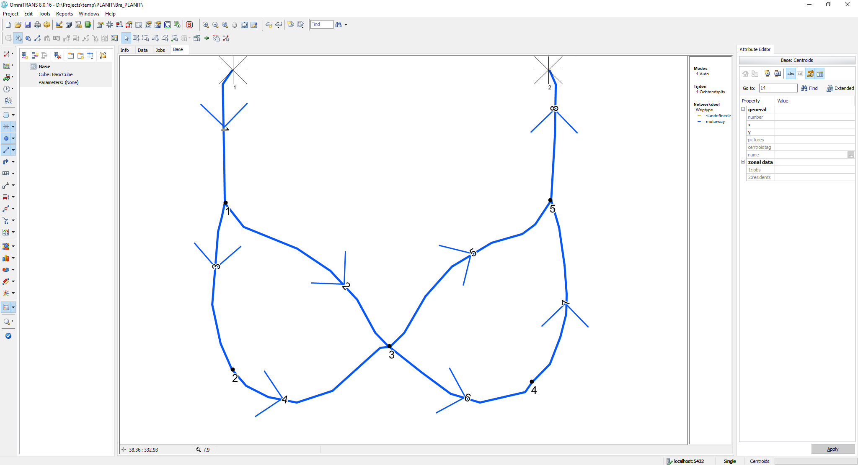

Figure : one OD, four route network.

**Length:**

* All links have a length of ***2 km***

**BPR**:

* All links use a BPR cost function with ***alpha: 0.5*** and ***beta: 4.0***

**Link properties:**

* All links have a maximum speed of ***100 km/h***
* Capacity per lane:
  + **Link 1:** 4 lanes, 2000 veh/h/lane (8000)
  + **Link 2:** 2 lanes, 1500 veh/lane (3000)
  + **Link 3:** 2 lanes, 2500 veh/lane (5000)
  + **Link 4:** 2 lanes, 2000 veh/lane (4000)
  + **Link 5:** 1 lane, 2000 veh/lane (2000)
  + **Link 6:** 2 lanes, 1500 veh/lane (3000)
  + **Link 7:** 1 lane, 2000 veh/lane (2000)
  + **Link 8:** 1 lane, 2000 veh/lane (2000)

**Demand:**

* The travel demand from 1 🡪 2 is set to **80*00 veh/h***

**Simulation:**

* Simulation time, i.e. period is ***1 h***

The equilibrium result after 500 iterations using regular MSA smoothing should yield the following link flow rates (Using OmniTRANS 8.0.16 and OTTraffic):

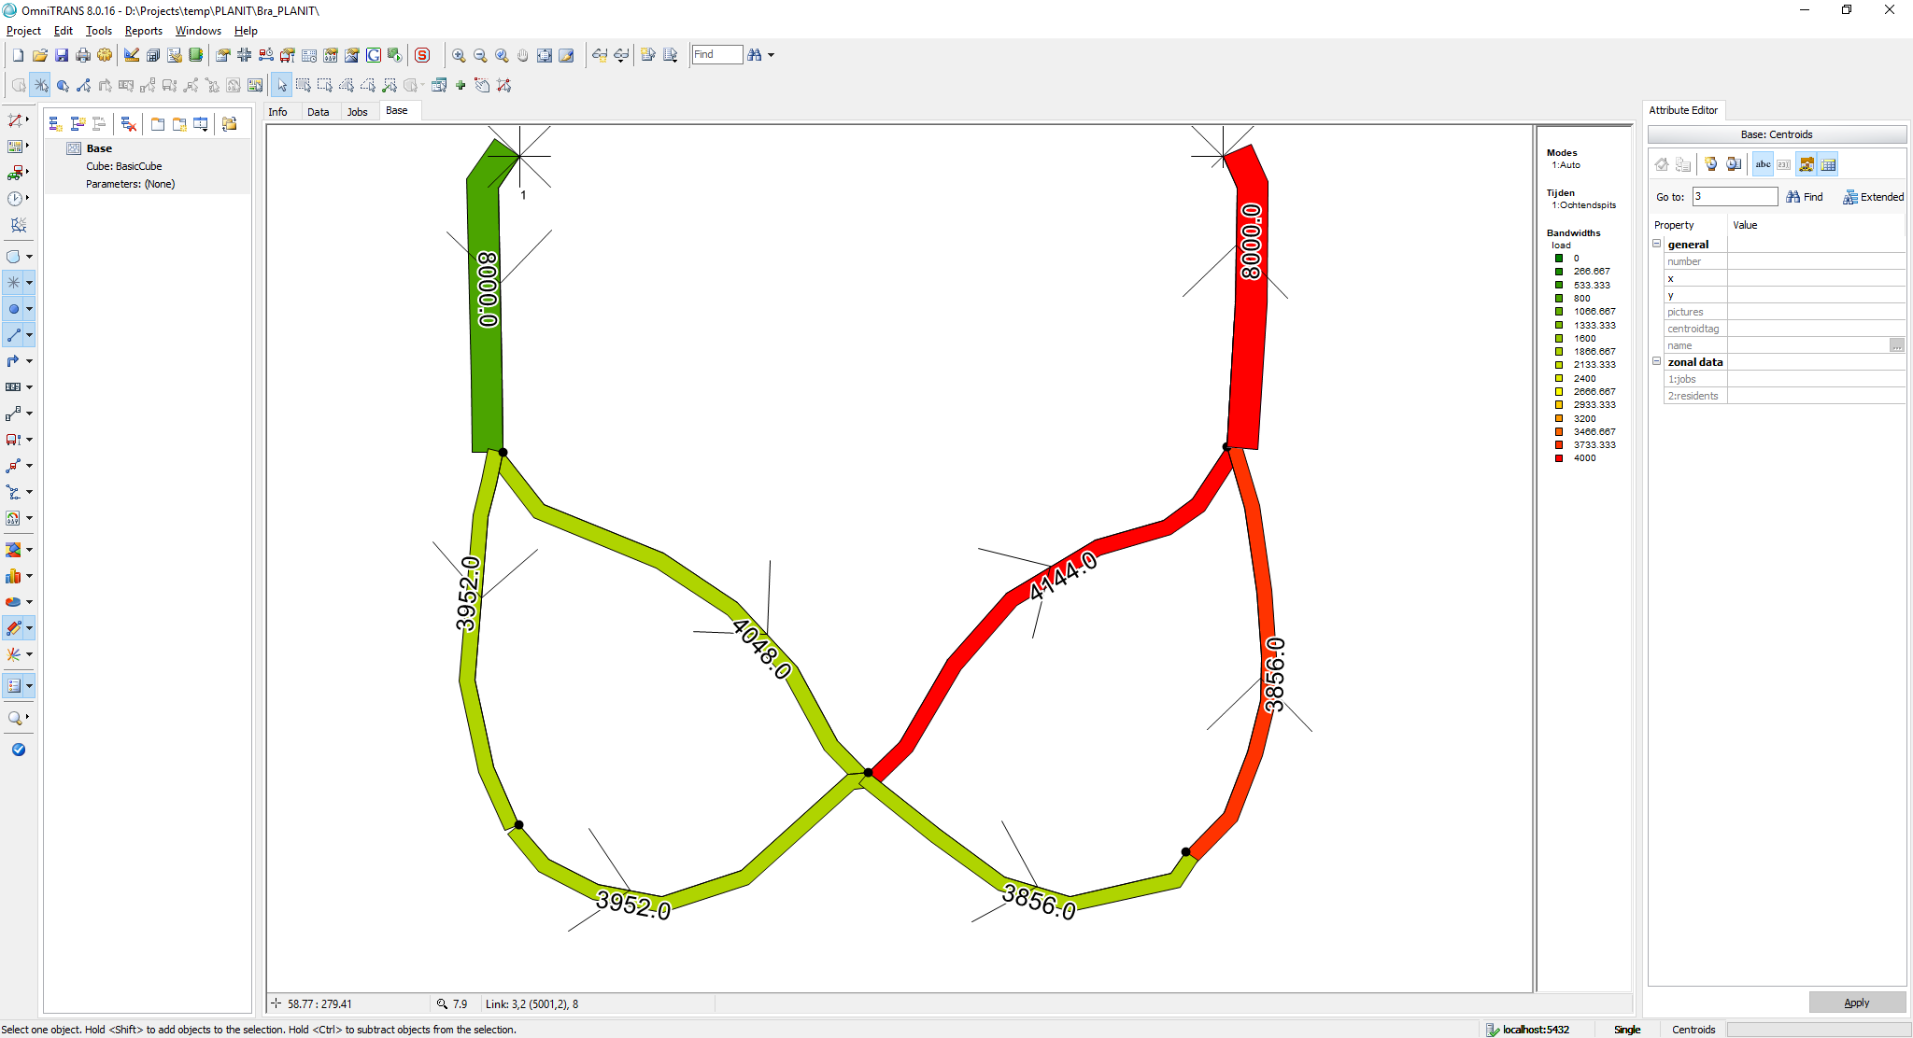

Figure : Equilibrium flow rate

Below the generalised link costs which consist of travel time (h) only:

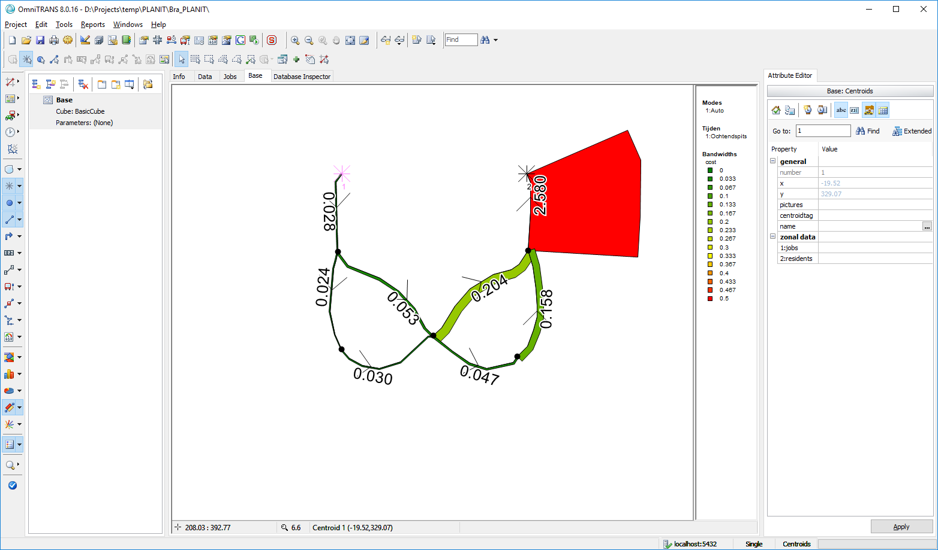

Figure : Generalised link costs in travel time (h)

## Test Case 4 (Hypercube): 4 zones – 16 ODs with interactions

The network looks like the following:

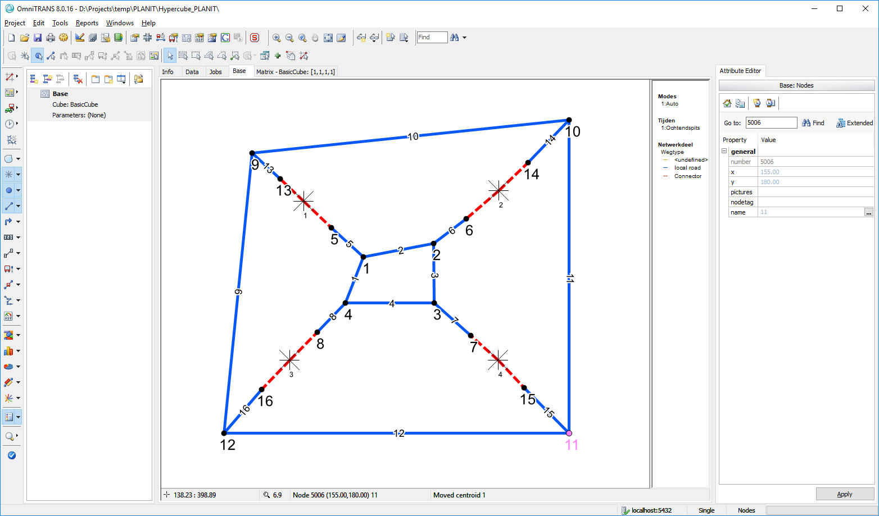

Figure : Hypercube network layout

**Length:**

* All links have a length of **1 *km***except for
  + Links 1 and 2 have a length of **0.9 km**
  + Links 11 and 12 have a length of **3 km**
  + Link 9 and 10 have a length of **2.9 km**

**BPR**:

* All links use a BPR cost function with ***alpha: 0.5*** and ***beta: 4.0***

**Link properties:**

* All links are bi-directional
* Regular (blue) links:
  + have a maximum speed of ***100 km/h***
  + Capacity per lane: **1500 veh/h/lane**
  + Have **1** lane
* Connector links (dashed red)
  + Have a maximum speed of **50 km/h**
  + Capacity per lane **1000 veh/h/lane**
  + Have **10** lanes

**Demand:**

* The origin – destination travel demands are given in the table below

Table : OD travel demands for the simulation duration

|  |  |  |  |  |
| --- | --- | --- | --- | --- |
| **From/to** | **1** | **2** | **3** | **4** |
| **1** | 100.000 | 200.000 | 300.000 | 400.000 |
| **2** | 200.000 | 400.000 | 600.000 | 800.000 |
| **3** | 300.000 | 600.000 | 900.000 | 1200.000 |
| **4** | 400.000 | 800.000 | 1200.000 | 1600.000 |

**Simulation:**

* Simulation time, i.e. period is ***1 h***
* *500 iterations*
* *Epsilon gap set to 0 to ensure we run the full 500 iterations*

Link flow results are shown below per link direction

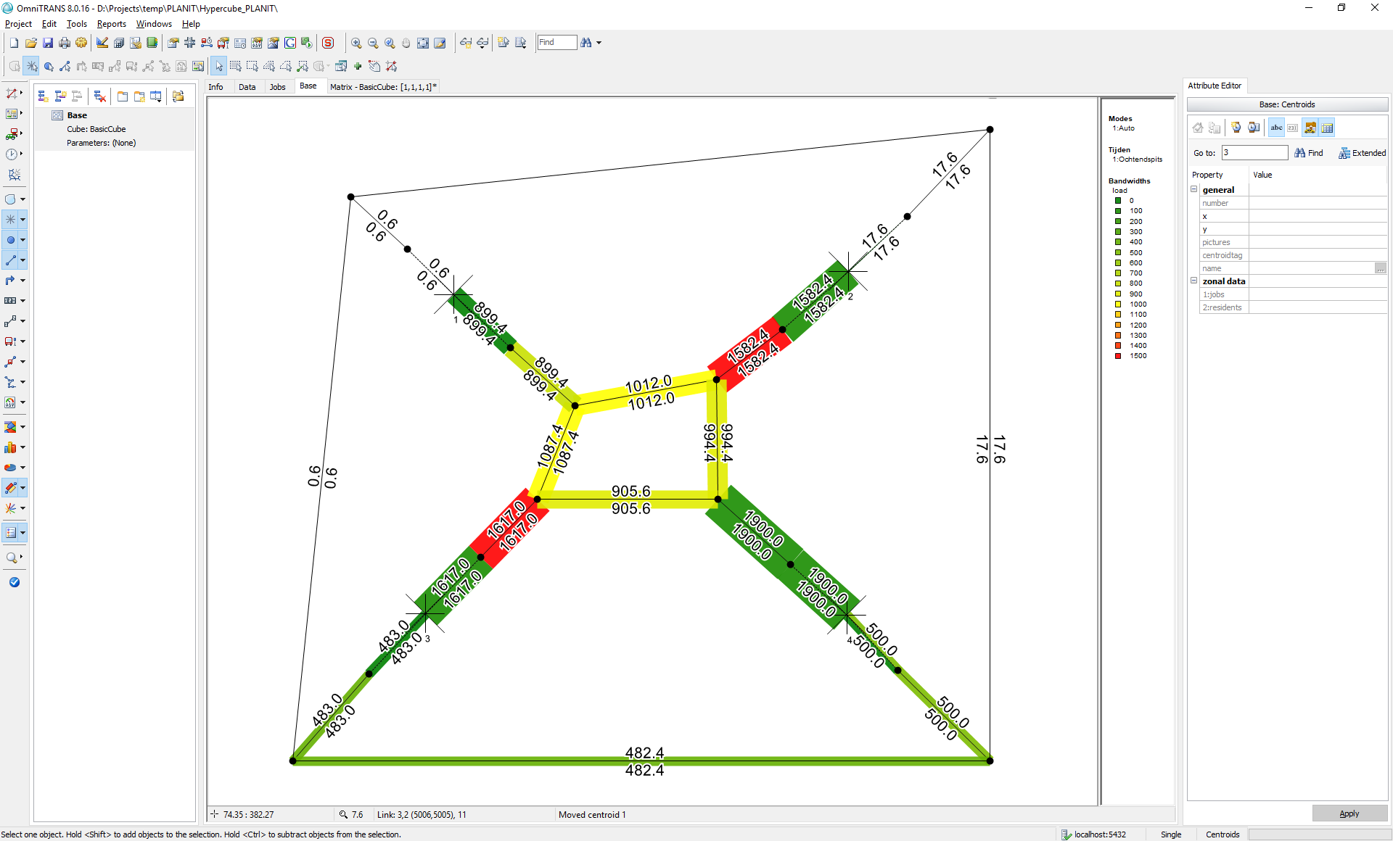

Figure : Hypercube network equilibrium flow rates (veh/h)

The generalised link costs associated with each link (direction) are shown below in travel time (h)

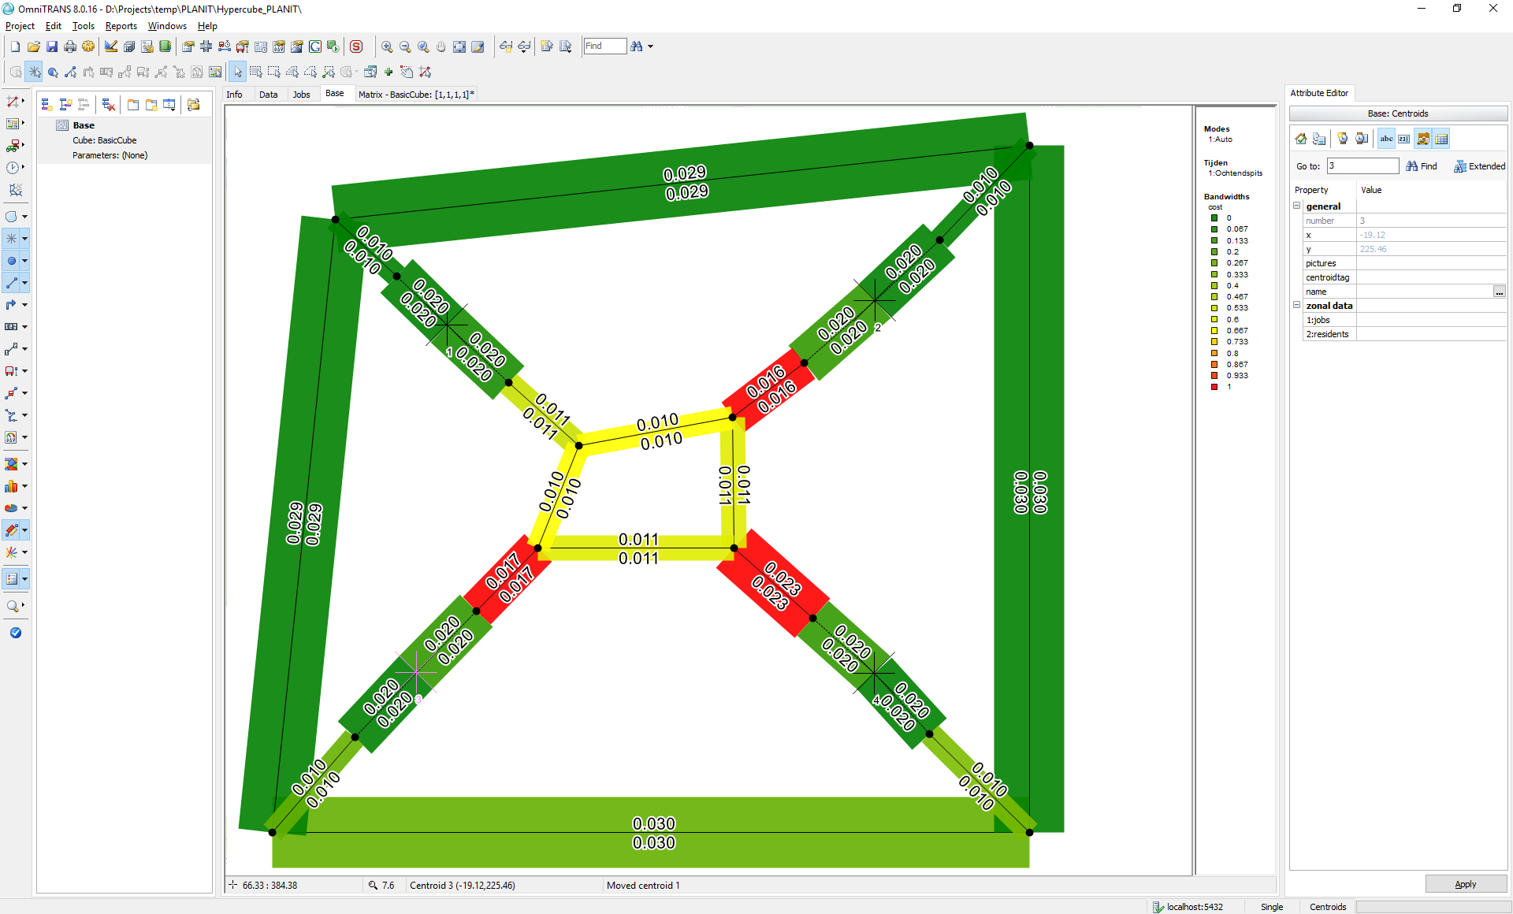

Figure : Hypercube network equilibrium link travel times (h)

## Test Case 5 (Mountain): 2 zones – 2 modes

This is a testcase for multi-modal assignment using two modes (cars, trucks). Trucks are allowed on all but the middle link (which represents an inner city of some sort. Hence, the network looks like the following:



Figure 13: one OD, three route, two mode network.

**Length:**

* All links have a length of ***1 km***, except for links 4 and 5 which are ***2 km*** in length

Modes:

* Mode 1: cars have a pcu=1
* Mode 2: trucks have a pcu of 2.5

**BPR**:

* All links use a BPR cost function with
  + Cars (mode 1): ***alpha: 0.5*** and ***beta: 4.0 for all links***
  + Trucks (mode 2): ***alpha: 0.8*** and ***beta: 4.5 for all links, except link 2 where trucks are not allowed***

**Link properties:**

* All links have a capacity of ***1200 veh/h/lane***.
  + Cars (mode 1): maximum speed of ***60 km/h*** and a
  + Trucks (mode 1): maximum speed of **5*0 km/h***
* All links have ***1 lane***, except for links 1 and 3 who have ***3 lanes***

**Demand:**

* The travel demand from 1 🡪 2 is set to
* Mode 1: ***3000 veh/h***
* *Mode 2:* ***600 trucks/h***

**Simulation:**

* Simulation time, i.e. period is ***1 h***.

The result after 100 iterations using regular MSA smoothing should yield the following (mode specific) link flow rates (Using OmniTRANS 8.0.16 and OTTraffic):

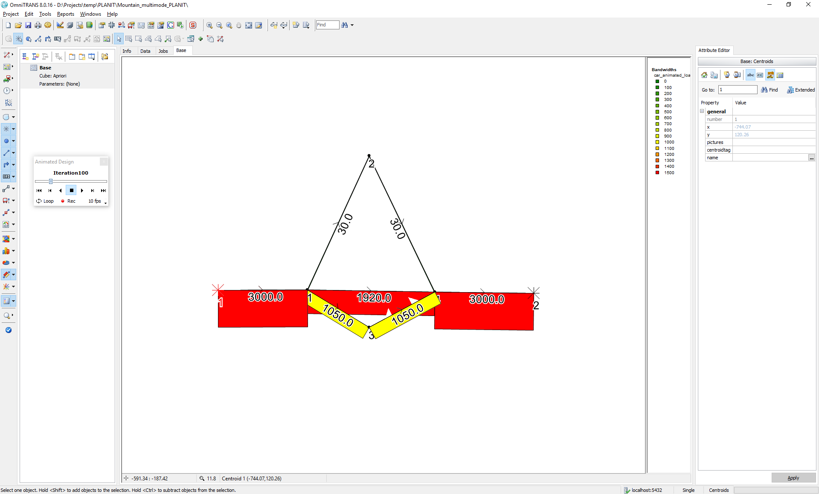 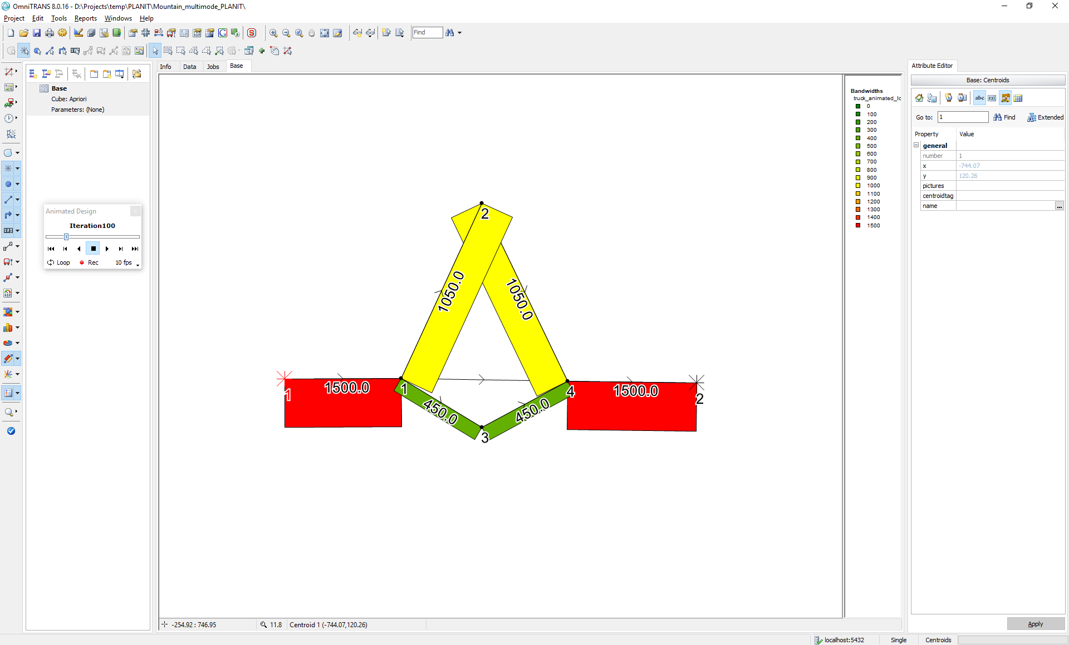(a) (b)

Figure 14: (a) car flow rates after i=100, (b) truck flow rates after i=100.

and link costs:

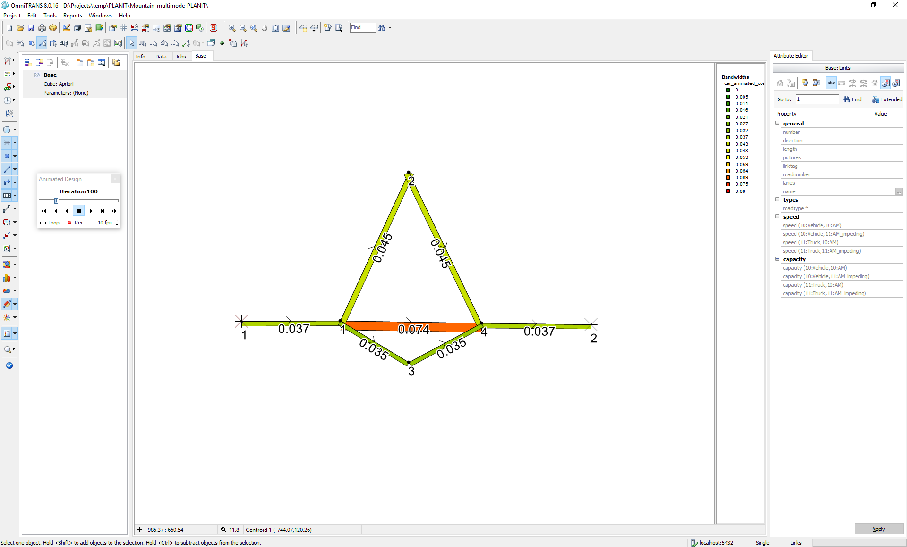 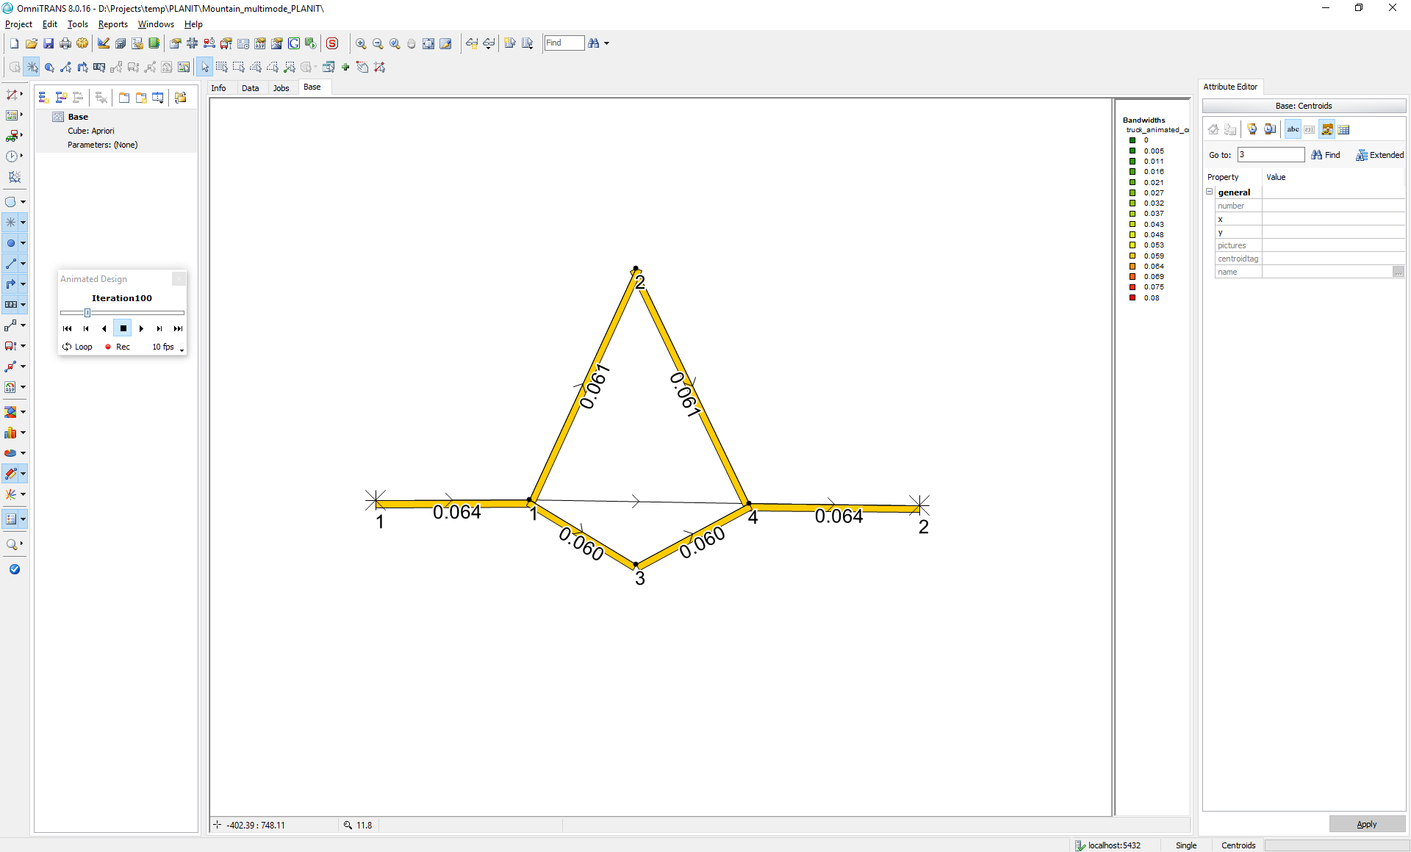

(a) (b)

Figure 15: (a) car link costs (h) after i=100, (b) truck link costs (h) after i=100.

The result after 500 iterations using regular MSA smoothing should yield the following link flow rates (Using OmniTRANS 8.0.16 and OTTraffic):

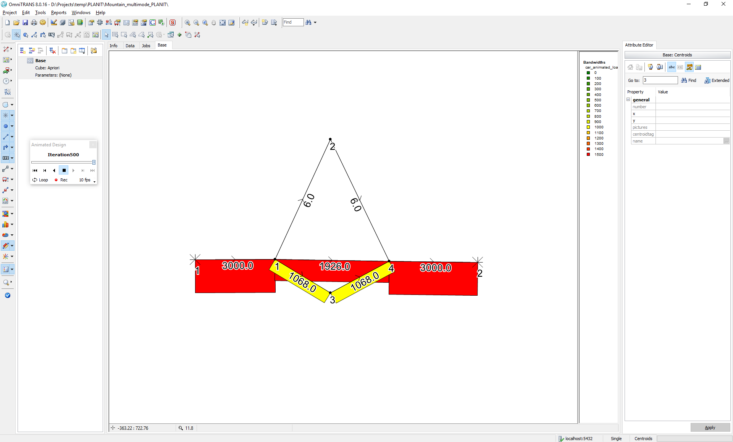 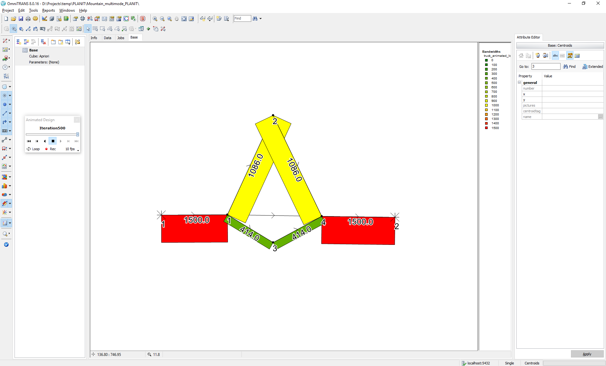

(a) (b)

Figure 16: (a) car flow rates after i=500, (b) truck flow rates after i=500.

and link costs:

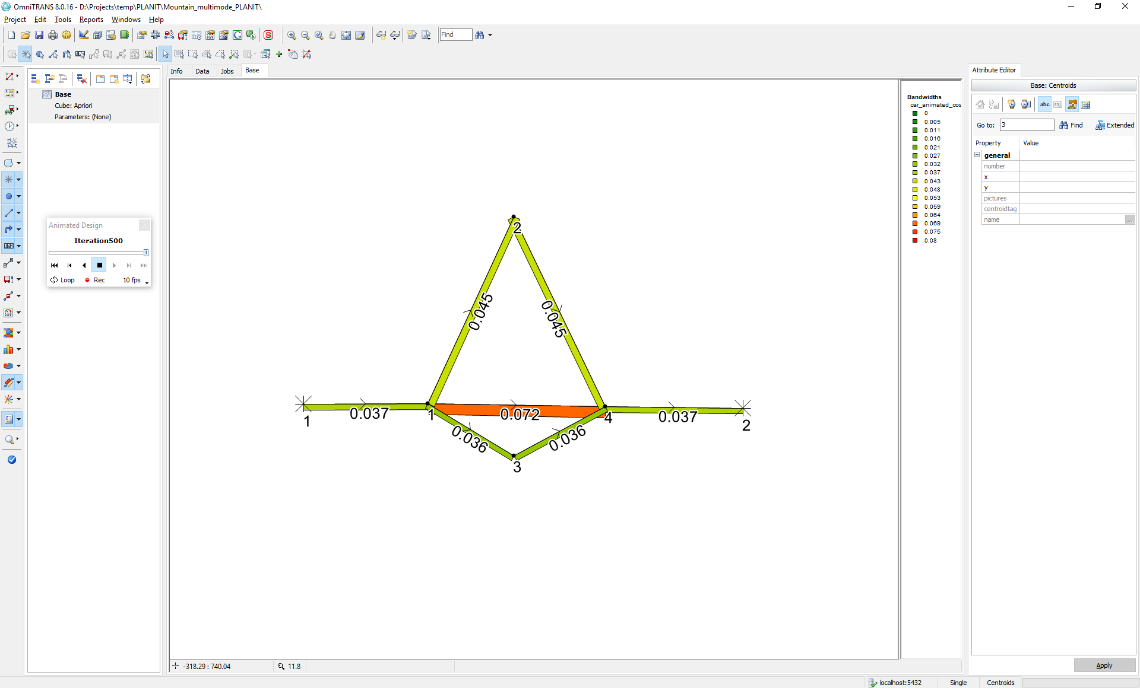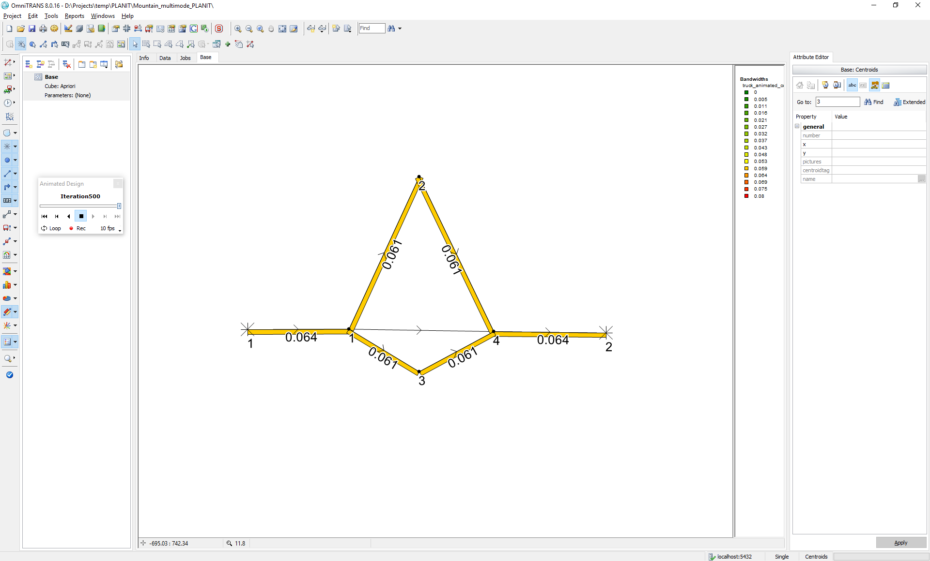

(a) (b)

Figure 17: (a) car link costs (h) after i=500, (b) truck link costs (h) after i=500.